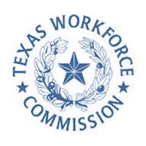

Final Agenda

Adult Education and Literacy Advisory Committee
March 27th, 2024
1:30 PM Central Standard Time
Texas Workforce Commission
https://zoom.us/j/94591238552

Adult Education and Literacy Advisory Committee Members:
Jauneen Maldonado, Leslie Cantu, Cindy Fisher, Kristina Hartman, Dr. Ben Stratford, Karla Flanagan, Ernest Lewis

Agenda:

TWC Welcome

State Director Opening Remarks
    - Commissioners Remarks

TWC AEL Updates

AEL 101 – Meeting for New or Existing Members

AEL Statewide Competition

AEL Strategic Plan Updates

Progress Report

Statewide Initiatives

- Committee Business and Discussion
      - Putting Recommendations Into Action
        - Statewide Needs Assessment Scope

