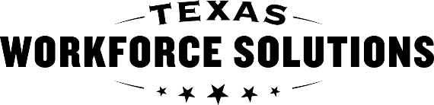 | Vocational Rehabilitation Division  Texas Workforce Commission  Permission to Collect and Notice to Disclose- National Student Clearinghouse

VR5063 Instructions

Purpose
The purpose of the VR5063 is to document a customer’s consent to exchange information with National Student Clearinghouse, a source that houses post-secondary student data. The credential information received from National Student Clearinghouse may be used to satisfy reporting and documentation requirements for federal performance measures related to credential attainment.
The VR5063 is filled out, signed, and dated by the customer, parent, guardian, or representative via SARA. If the customer refuses to sign, a data exchange with National Student Clearinghouse will not occur. The completed VR5063 is kept in the customer’s virtual case file for the life of the case.

When to Use the VR5063
Staff may use the VR5063 with any customers participating in education and training services.

Pre-Filled Data
The form has been pre-filled with as much data as possible to complete the data exchange.

Instructions
- List customer’s name, date of birth, Case ID, and phone number.
- Explain the purpose for disclosure, as pre-filled on the form. If there is another purpose to disclose, select Other and describe the purpose.
- The next section explains that TWC-VR is authorized to exchange information with the National Student Clearinghouse and lists the contact information for the National Student Clearinghouse.
- This next section explains the requested information about treatment or attendance covers any periods of time relevant to Customer’s education information until revoked or expired.
- The Information Subject to Disclosure section is pre-filled for educational records and grades from the National Student Clearinghouse. If there is other information to disclose, check Other and describe the information.
- VRC reviews with the customer the Acknowledgement of Notice section prior to signing. This includes informing the customer that TWC-VR may need to disclose personal information, such as name, DOB, and SSN to NSC to obtain educational records.
- Complete the signature section, as applicable.

