What is depreciation?
Understanding depreciation and how it impacts your financials.
Video: https://youtu.be/URQqFWdqQNo
Introduction
Depreciation can be complicated and confusing, but if you make any single asset purchases or property improvements over $2,500 for your business, such as cars, furniture, computers, a new roof, or have a home-based child care program or a facility that you own, you need to understand depreciation and how it can impact your child care business.
In this guide, we’ll review the basics of depreciation and how it works so you can understand when you need to prepare for higher taxes and when you don’t.
This document should not be considered tax advice. Please consult with your tax preparer or accounting professional for specific guidance and information regarding depreciation for your business.
Key Terms
Asset - property you acquire to help produce income for your business. Assets are subject to depreciation however, the IRS allows you to deduct the cost in full of those $2,500 or less. An asset is a single item, not a group of items. For example, a sofa that costs $3,000 rather than 10 chairs that were $300 each.

Depreciation - an annual income tax deduction that allows you to recover the cost or other basis of certain property over the time you use the property. Usually, you must depreciate single item purchases over $2,500.

Improvement – a renovation that enhances the value of or improves the life of property.

Repair – fixing the normal "wear and tear" of an item, such as replacing shingles that fell off, but not the whole roof

Time-Space – a calculation that allows home-based child care businesses to determine their business use of certain property. Providers must first apply time-space to the item or property before calculating allowable depreciation. Learn how to calculate your time-space here.
What is depreciation?
Whenever you make a business purchase that you will use for more than one year, the Internal Revenue Service (IRS) requires it to be depreciated. This means to write off the cost on your business taxes over time (rather than the year when you purchase it). The disadvantage is that instead of getting a deduction in one year, you get it slowly, over a number of years. Depreciation can apply to many things in your business including:
- Furniture
- Dishwashers and other appliances
- Computers
- Buildings and renovations
- Vehicles

Why do you need to understand depreciation?
Typically, when you have an expense, it is fully deducted in that year “offsetting” the same amount of revenue earnings. Depreciation creates different timing for your revenue and expenses that can increase your taxes when you make a large purchase or improvement but lowers it over future years. For example, let’s say you buy a $100 table. You made $100 and you get to deduct $100, so the impact on your taxes is $0 – since the $100 was spent on a deductible expense.
Depreciation changes this offset. Let’s say you used $20,000 in revenue to purchase a new van. In this case, your taxes would reflect the $20,000 in revenue, but you would only be able to deduct $4,000 in the first year (we’ll explain why later). As a result, you would have $16,000 in taxable revenue (that is, the $20,000 - $4,000 in depreciation leaves $16,000 in revenue). Since many providers aren’t expecting this additional taxable income, it can take them by surprise at the end of the year, causing problems as they find money to pay their tax bill.
What is subject to depreciation?
To determine if a purchase that you make for your business is subject to depreciation you need to ask the following questions.
- Is the item “ordinary and necessary” for your business? – that is, do you need this to run your business? This is an interesting opportunity for family child care business owners since it may open up home improvements to qualify as deductions (more on that later in this resource).
If it is, then move to the next question. If the item is not “ordinary and necessary” for your business, then it is a personal expense that is not deductible on your business taxes at all.
- Can the item last more than one year? – For example, paper towels will likely be used up in a year, so they would not be eligible. However, a desk or a newly installed deck (for a family child care provider) would be items that will last more than one year.
If the item can last more than a year, then move to the next question. If the item cannot last more than one year, then treat it as a typical business expense that would not be subject to depreciation.
- Is the value more than $2,500? – Any item, even one that could last for years, that has a value of less than $2,500 is considered a “safe harbor” where they can be expensed in one year and will not be subject to depreciation. Keep in mind, that this is a per-item limit. For example, if you purchased 50 chairs for $100 each, even though the total bill was $5,000, each chair is less than $2,500 so depreciation will not need to be applied.
If the value is more than $2,500, then move to the next question. If it is less than $2,500, then treat it as a typical business expense.
- Is this a repair or maintenance cost? – Costs to repair or maintain items for your business, including your home for family child care providers, can be expensed in one year and will not be subject to depreciation. For example, let’s say you have your roof shingles repaired and it cost $3,500. As a repair, you would still be able to deduct it in one year and depreciation will not be applied.
If it is not a repair or maintenance cost, you’ll need to depreciate the item. If it is a repair or maintenance cost, report it as an expense on your tax return.

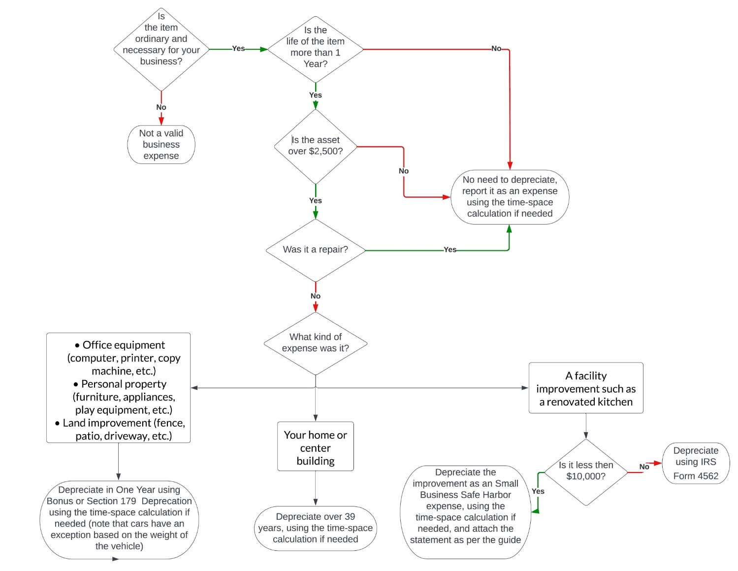

Family Child Care Providers
There are two other considerations in determining if an item is subject to depreciation for family child care providers. First, if an item is exclusively used for your business (for example, a business computer), 100% of the depreciation can be applied to your business. However, if an item is mixed with personal and business use, like a new cooling system, you will need to determine the amount of business use (and deductible amount) using the time/space calculation.
Second, family child care providers can deduct the depreciation on their homes. Home depreciation is based on the value of the home and any renovations (improvements to the home that increase its value, such as a new deck), but not the value of the land itself. The best way to determine the land value is through your local assessor's office and then subtract that amount from your total value of your home. For example, if you purchased your home for $400,000 and the assessor valued the land at $75,000, then your total depreciable amount would be $325,000.
When you sell a home where you operated a business, you need to pay a tax on the depreciation, even if you did not deduct it or if you aren’t even in business anymore. The total amount will be taxed based on your return and the tax bracket for your income for the given year. Accordingly, it is a good practice to deduct your home when you can to get the benefit of value that will be eventually taxed.
How do I depreciate an item?
Once you have identified a depreciable item, you need to determine how you can expense it.
The most basic way to figure out how much you can expense in a given year is called straight line depreciation (though there are some other methods your tax professional may use).
In this calculation, you take the total cost of the item and divide it by the total number of years that the IRS says is the life of the item. Here are some common useful life values from the IRS:
- Office furniture, fixtures, and equipment - 7 years
- Automobiles – 5 years
- Land improvements – 15 years
- A house or building used in part or whole for business – 39 years
You can find the current list of all life values in IRS Publication 946, here.
For example, a land improvement such as a new driveway is considered by the IRS to have a 15-year life. So, if you paid $15,000 for the new driveway, you could deduct $1,000 a year in depreciation for it, for 15 years ($15,000 divided by 15).
Accelerating depreciation
Another option in addition to straight line depreciation is to accelerate your depreciation faster which allows you to expense your purchase quicker, such as during one year. Namely, you can accelerate your depreciation through three special rules:
- Section 179 depreciation is allowable for physical property used for your business more than 50% of the time. Examples of allowable property are office equipment, furniture, vehicles, and most other assets that are not buildings, or improvements to your building (including a home used for business). If you are a family child care provider who wants to use this depreciation method for an improvement to your home, you will need to show 50% or greater business use. For example, for a vehicle, such as a van for transporting children, you will need to show that the miles driven for business purposes are at least 50% or of the total miles driven for a year if you are using this method (alternatively, you can depreciate the car based on the percentage of use for business versus personal driving using straight line depreciation).
For the 2023 tax year, you can write off up to $1.16 million in eligible Section 179 expenses. If you have over $1.16 million in eligible expenses, you may qualify for Bonus Depreciation. Like Section 179, this option has specific requirements, such as the useful life of the item and the percentage of business use. However, the percentage of depreciation allowed will decrease annually until it ends completely in December 2026.
The one exception is cars limited to a single-year deduction based on weight. For vehicles over 6,000 pounds, but less than 14,000 pounds, it is $26,200. Make sure you prorate your costs based on the percentage of business use. For example, if you take the total miles driven in the year for your car and 65% of the miles are for your business, you can only depreciate 65% of the purchase price.
- The Safe Harbor for Small Taxpayers can provide another vehicle for accelerating depreciation. This rule comes out of the IRS Tangible Property Regulations and allows providers to deduct repairs or improvements to the home (for family child care providers) or a facility (for centers) that are the lessor of $10,000 or 2% of the unadjusted basis (that is the value of the property less the value of the land). For example, let’s say you owned a child care center facility that was worth $350,000 and the land is worth $50,000. The unadjusted basis would be $300,000. Two percent of the unadjusted basis would be $6,000. So an improvement, like adding an awning that was $5,500, could be deducted in one year.
For family child care providers, you need to also include the time/space calculation. So, let’s say a provider’s home is valued at $400,000 and the land is $65,000. Their unadjusted basis would be $335,000. Further, let’s assume the time/space calculation shows the provider is using the home for business 35% of the time. Now, the unadjusted basis would be $117,250 (that is 35% of $335,000). Two percent of $117,250 is $2,345. So, costs under $2,345 related to repair or renovation could be deducted in one year rather than depreciated over time.
If you use this rule, make sure your preparer includes a statement reading: “Section 1.263(a)-3(h) De Minimis Safe Harbor Election
Your name _________________
Your address __________
EIN or Social Security Number __________
For the year ending December 31, 20__ I am electing the safe harbor election for small taxpayers under Treas. Reg. Section 1.263(a)-3(h) for the following: (list your improvements).”
It is important to note that state limitations can vary, so depreciation, as described above, may only apply to your federal tax return.
Record Keeping
It is critical to have clear records of your purchases for the depreciation that include what you purchased, when, the total cost, and any indication of the amount of business use (for example was it 100% for business or a mix of business and personal use).
It is also important to keep records of your remaining depreciation so that your tax preparer knows to apply it to future years.

Disclaimer: The information contained here has been prepared by Civitas Strategies Early Start and is not intended to constitute legal, tax, or financial advice. The Civitas Strategies Early Start team has used reasonable efforts in collecting, preparing, and providing this information, but does not guarantee its accuracy, completeness, adequacy, or currency. The publication and distribution of this information is not intended to create, and receipt does not constitute, an attorney-client or any other advisory relationship. Reproduction of this information is expressly prohibited.

