**Desk Aid - Metrix Statewide Initiative**

# Boards must ensure that for each individual enrolled in Metrix services, appropriate staff documents the following in a WorkInTexas.com WIOA Program Application:

* + Adult, Dislocated Worker, or Youth program eligibility, as applicable, including all required information.
  + For new enrollments staff must complete the WIOA Application Wizard in WIT.com before an individual can be provided Metrix Services.

**Adding Adult/DW Metrix Services**

**Certification Track Training and General Online Coursework**

# Before staff enter the applicable Metrix Service, please look at the Activities/Enrollment/ Services tab Tab in WIT to make sure the WIOA **service sequencing** has been entered correctly for the Adult or Dislocated Worker.

# WIOA **Adult and Dislocated Worker** Programs Sequence of Services

* **1st Service must be**: 203 - Comprehensive Objective Assessment
* **2nd Service must be**: 205 - Individual Employment Plan (IEP)
* **3rd rule**: All remaining services become available except for Follow-up Services.

If services 203 Comprehensive Objective Assessment and 205 Individual Employment Plan (IEP/EDP) does not show as a selection in the dropdown; this means that one or both services were not entered prior to conversion.

Staff will need to go back to Program Ribbon to open Activities/Enrollment/ Services tab tab to verify if these services have been entered. If one or both have not been entered; **the missing services must be provided and entered** before the system will allow any other services to be added. Please note:

* Staff may see that the service 68 converted; **however, this will not suffice for the 205 required service; the 205 service must be entered.**

# Staff must confirm that the Metrix grant has been added to the **Grants** section of the individual’s eligibility summary, **by Board Staff**. To add the Metrix grant to the Grants section in WIT, Board staff must:

**PATH** > Eligibility Summary; Board staff must -Select from the **Action Column**, to add the appropriate Grant.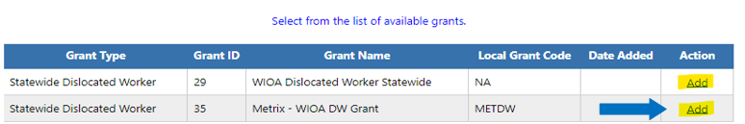

# Select **Add** and click **Finish** at the bottom of the page to save changes to the individual’s WIOA grant eligibility summary.

Program Tab


# Click **Return to Programs Tab**

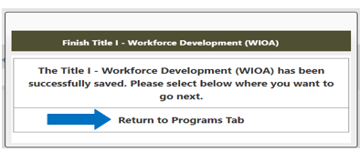

# Assist an Individual > Staff Profiles > Case Management Profile > Programs

* Scroll down to the **WIOA Program Ribbon**
* Click on Activities/Enrollment/ Services tab tab
* Click on Create activity /Enrollment/Service tab

**Page Displays:**

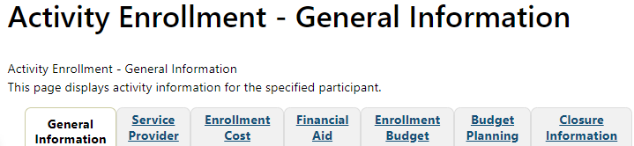

# Select the applicable Program Group for the participant you are assisting:

Examples of **Customer Program Groups –** (*Select the applicable fund)*

* ***93 - Statewide Adult***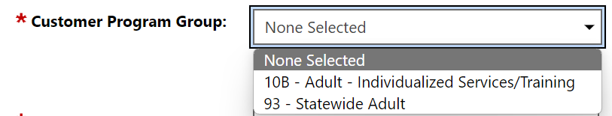
* ***96 - Statewide Dislocated Worker***

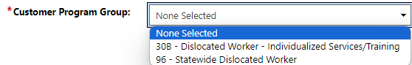

**LWDB** – Board area auto-populates; verify correct Board is displaying.

# **Office Location** – Select from the dropdown your office location.

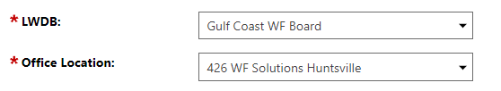

# Select **Grant** – Add the applicable WIOA Grant Name:

* WIOA Statewide Dislocated Worker **METXDW – Metrix – WIOA DW Grant**

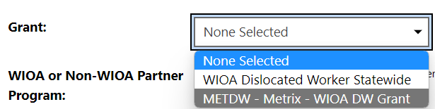

* WIOA Statewide Adult **METXA – Metrix – WIOA Adult Grant**

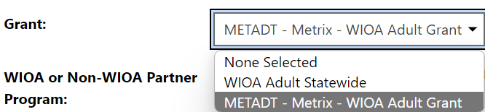

# Select **Activity Code**: 328 - Occupational Vocational Training (Non-ITA) for Metrix Industry Certification Track Training and Assistance **or**

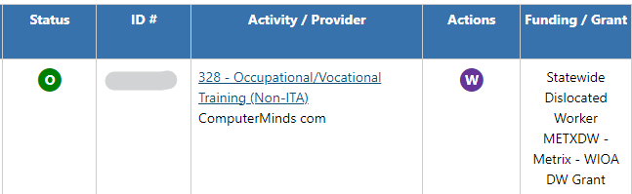

Select **Activity Code**: 269 - Short-term Work Readiness Services for General Online Coursework, including job readiness courses or other online courses not intended to lead to Metrix Industry Certification

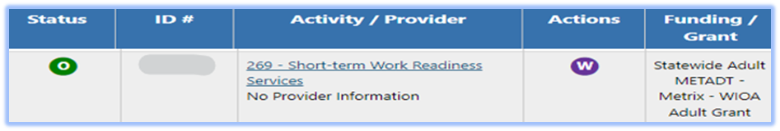

# Enter the following dates as the Actual Begin Date and Projected End Dates:

* **Actual Begin date**: The date the participant begins receiving Metrix Industry CertificationAssistance
* **Projected End Date**: Enter the estimated date of completion for Projected End Date (this date cannot be more that 31 days).

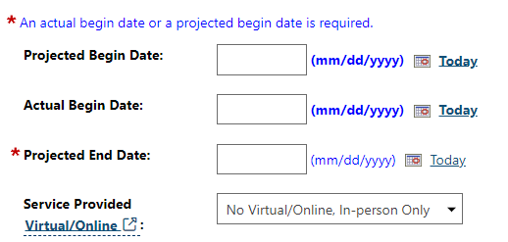

**Recommendation:** BSS TA recommends that staff enter the projected end date as the last day of the month and for the next month’s entry staff can extend the projected end date for the end of the following month.

# If staff select the service 328 Occupational/Vocational Training (Non-ITA), the system will add the required question below:

* Participant has been issued an ITA and the ITA will pay for this service. *Select* ***No***

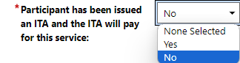

# Add a Case Note

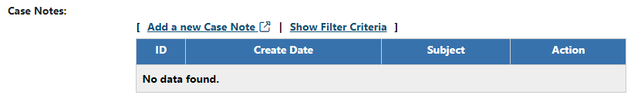

# Click Next buttonto continue through the Activity Enrollment – General Information Tabs:



**Service Provider Tab –** this tab will auto-populate.

* *Service Provider*
* Select Provider
* Select Service, Course, or Contract
* Occupational Training Code

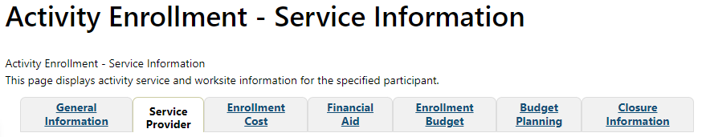

**Enrollment Cost Tab**

* *Enrollment Cost*
* Metrix will not have any activity costs. All cost fields should be set to zero.

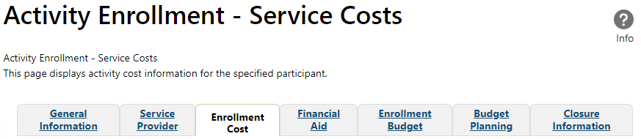

**Closure Information Tab**

* Closure Information (once training and assistance services are completed) – This is **only required for the Certification Track** training; this is not required for the General Online courses.
* Enter the final date of certification assistance **(which may be the date of certification testing)** for the Last Activity Date of the service.
* Select appropriate Completion Code.

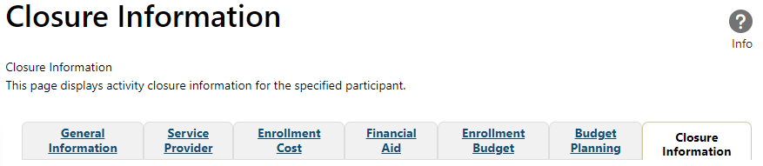

# Metrix Tracking Process After Enrollment

* After staff have determined eligibility and opened the **service 328** in WIT, the Board’s Metrix Administrator must also add the participant’s information to the Board’s SharePoint list PRIOR to notifying Metrix through email.
* Board’s Metrix administrator will email Metrix the customer’s name and Certification training track to [certifications@metrixlearning.com](mailto:certifications@metrixlearning.com), which will trigger Metrix staff, to reach out to BSS to confirm participant’s eligibility and data entry in both WIT and the Metrix SharePoint document.
* Once this has been verified, Metrix staff will reach out to the participant to provide them access to the Metrix courses.
* **For the Service 269 only** - The Board’s Metrix administrator will enroll the customer in the Metrix Portal at [https://tx.metrixlearning.com/](https://gcc02.safelinks.protection.outlook.com/?url=https%3A%2F%2Ftx.metrixlearning.com%2F&data=05%7C02%7Cmargaret.corley%40twc.texas.gov%7C6aa3d8c552c949f73b1808dc9142fe3c%7Cfe7d3f4f241b4af184aa32c57fe9db03%7C0%7C0%7C638544964136841412%7CUnknown%7CTWFpbGZsb3d8eyJWIjoiMC4wLjAwMDAiLCJQIjoiV2luMzIiLCJBTiI6Ik1haWwiLCJXVCI6Mn0%3D%7C0%7C%7C%7C&sdata=nI6ECfgUKUOwoyVI0%2FlexS6KB278IEMN5xqtP%2B%2FICbU%3D&reserved=0) where the customer will be provided with Metrix access to the General Online Coursework Catalog
* If the Administrator has an issue enrolling a customer, the Administrator may reach out to [customersupport@metrixlearning.com](mailto:customersupport@metrixlearning.com)

# BSS will update the Boards SharePoint List to reflect customers who have dropped or failed training. The Boards assigned Metrix Administrator must review the Boards Metrix SharePoint list for updated customer training information and available slots to use.

* If it is determined the individual ***Dropped*** from their training and documentation shows that no charges will be forthcoming, Staff will close the service with completion code as ***Dropped out of Activity*** for this individual*,* so we can track slots and run a report to see Metrix outcomes. ***This slot for the Dropped customer would be available for use again.***
* If the customer took their **exam and failed**, Staff will close the services as ***Unsuccessful,*** and the customers slot would **not** be available for reuse.
* If the customer took their **exam and passed** Staff will close the service as ***Successful*** and their slot would **not** be available for reuse. They could be allowed to take a second certification if the Board has an available slot.

As a reminder, if your Board has met its occupational vocational training target, and needs any additional occupational vocational slots, Board staff MUST get prior approval from BSS before going over their assigned number of slots.

**Adding Youth Metrix Statewide Initiative Services**

**Certification Track Training and General Online Coursework**

Before Staff enter the applicable Metrix Service, please look at the Activities/Enrollment/ Services tab Tab to make sure the service sequencing has been entered correctly.

WIOA **Youth** Program

* **1st Service must be**: 412 - Comprehensive Objective Assessment - Youth Funded
* **2nd Service must be:** 413 - Individual Service Strategies (ISS) - Youth Funded
* **3rd rule**: All Youth Element services become available (remaining 400-series services)
* **4th rule**: At least one Youth Element service has been entered, then the remaining services become available except for Follow-up services.

When selecting a Service Code, If Services 412 Comprehensive Objective Assessment and 413 Individual Service Strategies (ISS) show as a selection option, this means that one or both of these services **were not** entered prior to conversion.

Staff will need to go back to Program Ribbon to open Activities/Enrollment/ Services tab tab to verify if these services have been entered. If one or both have not been entered; the **missing services must be entered** before the system will allow any other services to be added.

**Please Note:**

* For converted records Youth that were placed in the Short-Term Work Readiness (TWIST service code 84), converted in WIT as service 460 Short-Term Work Readiness - Youth. As of 4/15/2024 staff should enter service 459, which is Short-term Educational services.
* Staff may see that the service 68 converted; **however, this will not suffice for the 413 required service; the 413 service must be entered.**

# Case Manager must confirm that the Metrix grant has been added to the Grants section of the individual’s eligibility summary.To add the Metrix grant to the Grants section in WIT, staff must:

**PATH** > Click the Pencil Icon from the WIOA Application in order to edit the individuals Eligibility Summary. 

**Page Displays** showing WIOA Application, staff will click on **Eligibility Summary** page displays **Applicant Eligibility**

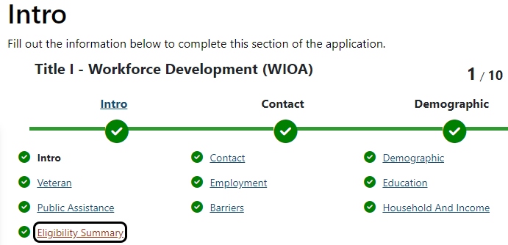

Scroll to bottom of page to add the appropriate grant from the **Action Column**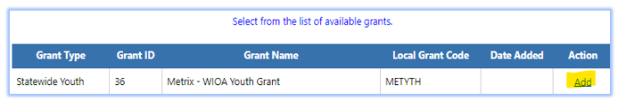

# Select **Add** and click **Finish** at the bottom of the page to save changes to the individual’s WIOA grant eligibility summary.



# Click Return to Programs Tab



# Assist an Individual > Staff Profiles > Case Management Profile > Programs

* **Scroll down to the WIOA Program Ribbon**
* **Click on Activities/enrollments/ services screenshot tab**
* **Click on Create activity/Enrollment/ Services tab screenshot**

**Page Displays:**



# Select the **Statewide Youth**:

# **Customer Program Group –** *(Select the applicable fund)*

* ***90 - Statewide Youth***

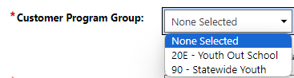

# **LWDB** – Board area auto-populates; verify that the correct Board is showing:

# **Office Location** – enter your office location.Add Office location

# Select Grant – Add the WIOA Youth Grant Name:

* Statewide Youth **METYTH – Metrix – WIOA YOUTH Grant**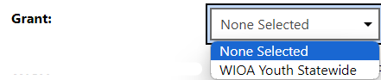

# Select **Activity Code 454** - Occupational Vocational Training (Non-ITA) - Youth Funded for Metrix Industry Certification Track Training and Assistance.Select activity code

* Select **Activity Code 459** - Short-term EducationalServices - Youth Funded for General Online Coursework, including job readiness courses or other online courses not intended to lead to Metrix Industry Certification Assistance

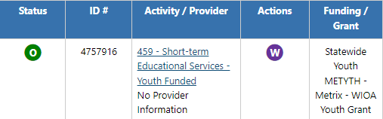

# Enter the following dates as the **Actual Begin Date** and **Projected End Dates**:

* Actual Begin date: The date the participant begins receiving Metrix Industry CertificationAssistance.
* Projected End Date: Enter the estimated date of completion for Projected End Date (this date cannot be more that 31 days).



**Recommendation:**BSS TA recommend that staff enter the projected end date as the last day of the month and for the next month’s entry staff can extend the projected end date for the end of the following month.

# If staff select the service 454 Occupational/Vocational Training (Non-ITA) – Youth Funded, the system will add the required question below:

# Select **No** for the question -Participant has been issued an ITA and the ITA will pay for this service.

**

# Add a new **Case Note**



# Click Nextto continue through the **Activity Enrollment – General Information Tabs:**



## Service Provider Tab – this tab auto-populated.

* *Service Provider*
* Select Provider
* Select Service, Course, or Contract
* Occupational Training Code



## Enrollment Cost Tab

* *Enrollment Cost*
* Metrix will not have any activity costs. All cost fields should be set to zero.



**Closure Information Tab**

* Closure Information (once training and assistance services are completed) - This is **only required for the Certification Track** training; this is not required for the General Online courses.
* Enter the final date of certification assistance *(which may be the date of certification testing)* for the Last Activity Date of the service.
* Select appropriate Completion Code.



# The **Closure Tab** will display. If staff are not closing the service, staff will select Exit Wizard screenshot

# Metrix Tracking Process After Enrollment

* After staff have determined eligibility and opened the **service 454** in WIT, the Board’s Metrix Administrator must also add the participant’s information to the Board’s SharePoint list PRIOR to notifying Metrix through email.
* Board’s Metrix administrator will email Metrix the customer’s name and Certification training track to [certifications@metrixlearning.com](mailto:certifications@metrixlearning.com), which will trigger Metrix staff, to reach out to BSS to confirm participant’s eligibility and data entry in both WIT and the Metrix SharePoint document.
* Once this has been verified, Metrix staff will reach out to the participant to provide them access to the Metrix courses.
* **For the Service 459 only** (Youth General Short Term Educational – General Online Courses). The Board’s Metrix administrator will enroll the customer in the Metrix Portal at [https://tx.metrixlearning.com/](https://gcc02.safelinks.protection.outlook.com/?url=https%3A%2F%2Ftx.metrixlearning.com%2F&data=05%7C02%7Cmargaret.corley%40twc.texas.gov%7C6aa3d8c552c949f73b1808dc9142fe3c%7Cfe7d3f4f241b4af184aa32c57fe9db03%7C0%7C0%7C638544964136841412%7CUnknown%7CTWFpbGZsb3d8eyJWIjoiMC4wLjAwMDAiLCJQIjoiV2luMzIiLCJBTiI6Ik1haWwiLCJXVCI6Mn0%3D%7C0%7C%7C%7C&sdata=nI6ECfgUKUOwoyVI0%2FlexS6KB278IEMN5xqtP%2B%2FICbU%3D&reserved=0) where the customer will be provided with Metrix access to the General Online Coursework Catalog
* If the Administrator has an issue enrolling a customer, the Administrator may reach out to [customersupport@metrixlearning.com](mailto:customersupport@metrixlearning.com)

# BSS will update the Boards SharePoint List to reflect customers who have dropped or failed training. The Boards assigned Metrix Administrator must review the Boards Metrix SharePoint list for updated customer training information and available slots to use.

* If it is determined the individual ***Dropped*** from their training and documentation shows that no charges will be forthcoming, Staff will close the service with completion code as ***Dropped out of Activity*** for this individual, so we can track slots and run a report to see Metrix outcomes.  ***This slot for the Dropped customer would be available for use again.***
* If the customer took their **exam and failed**, Staff will close the services as ***Unsuccessful,*** and the customers slot would **not** be available for reuse.
* If the customer took their **exam and passed** Staff will close the service as ***Successful*** and their slot would **not** be available for reuse. They could be allowed to take a second certification if the Board has an available slot.

As a reminder, if your Board has met its occupational vocational training target, and needs any additional occupational vocational slots, Board staff MUST get prior approval from BSS before going over their assigned number of slots.