Texas Workforce Commission
Vocational Rehabilitation Services
Dental Report
The information requested is necessary to help counselors determine treatment needs for the person named.
Return Information
Return Report To (Name): |  |  |  |  |  |  |  |  |  |  |  | Telephone Number:  ( )
Address: |  |  |  |  | City: |  |  |  | State: |  |  | ZIP Code:
Patient Information
Name: |  |  |  | Date of Birth: |  |  |  | Case ID Number: |  |  | Telephone Number:  ( )
Reported Disability:

Reason for Referral:

Examination and Treatment Record
To the dentist: Examination authorization does not allow for proceeding with definitive dental care. Complete all applicable items and return for treatment authorization.
Use charting system shown. One tooth number, one procedure, and one estimated fee per line. For prosthesis (fixed or removable), indicate teeth to be replaced.
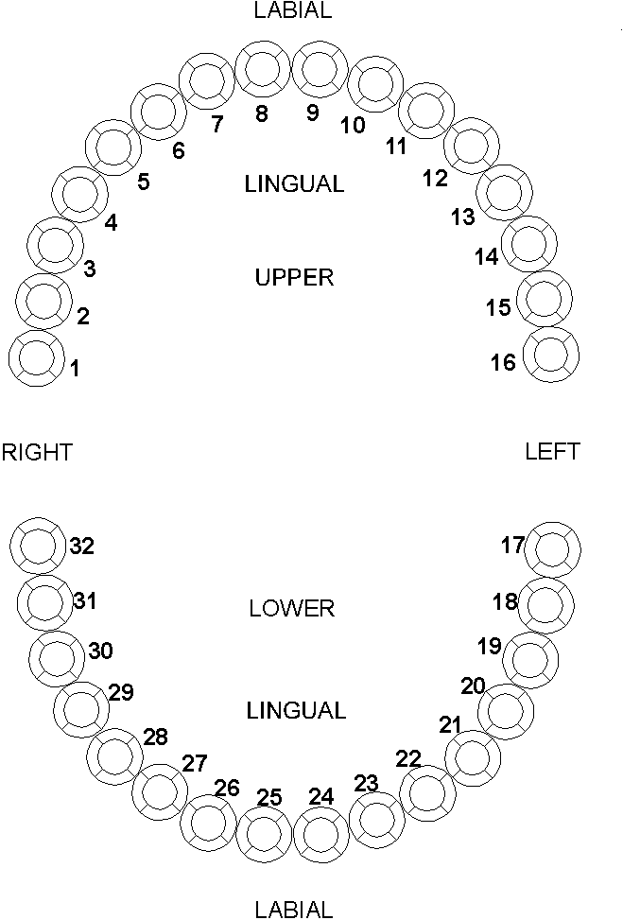  Mark “X” on the chart above to indicate missing teeth. | Tooth Number | ADA Code Number |  |  |  | Description of Services  (Including X-rays, prophylaxis materials used, etc.) |  |  |  |  |  |  | Estimated Fee |  | VR Use Only
Treatment period - number of months: |  |  |  |  |  |  | Total Fee:
Is any of the treatment for orthodontic purposes?  Yes No |  |  |  |  |  |  | Is the major dental condition:  acute slowly progressive static
If prosthesis, is this initial placement?  Yes No |  |  | If no, reason for replacement:
Give summary statement of condition of mouth:

Remarks for unusual services:

All information is to be treated as confidential.
Examinee has the legal right to see this report when the examinee requests.
Type or Print Dentist's Name: |  |  |  |  |  |  |  |  |  | Telephone Number:  ( )
Dentist’s Address: |  |  |  |  |  |  |  | City: |  | State: |  |  |  | ZIP Code:
Examining Dentist’s Signature:  X |  |  |  |  |  |  |  | Date of Examination:

