# Types and Documentation of Measurable Skill Gains

Under the Workforce Innovation and Opportunity Act (WIOA), five categories are used to document Measurable Skill Gains (MSGs). The categories are as follows:

* + - * Educational Functioning Level (EFL) gain
      * Attainment of secondary school diploma or its recognized equivalent
      * Report card or transcript showing satisfactory progress
      * Training milestone as demonstrated by a satisfactory or better progress report
      * Skills progression as demonstrated by successful passage of an exam

All participants who achieve a credential outcome are expected to have at least one documented MSG. Staff must document all applicable MSGs achieved by participants enrolled in education and training services. Case notes and appropriate documentation must be maintained to support all MSG achievements.

Pretest and posttest EFL gains must be documented in the Educational Functioning Level for Measurable Skills Gain ribbon of the appropriate WIOA or Trade Adjustment Assistance (TAA) program in WorkInTexas.com. All other MSGs are entered in the Measurable Skills Gain ribbon of the applicable WIOA or TAA program.

## EFL Gains

EFL gains are documented achievements of at least one EFL by a participant who is receiving instruction below the postsecondary education level at or during the time of participation.

These gains apply only to participants in education below the postsecondary level (students in high school, alternative high school, or a high school equivalency (HSE) preparatory course, including Adult Education and Literacy (AEL) courses) at the beginning of or during a period of participation. On the Education Information tab, School Status indicates one of the following:

* In-school, secondary school or less
* In-school, alternative school

EFL gains may be demonstrated by:

* an increase in one or more EFL indicated by results from approved pretest to posttest (see [Test Benchmarks for NRS Educational Functioning Levels](https://nrsweb.org/training-ta/ta-tools/assessment))—note that the same test must be used for both the pretest and the posttest, with gains based on scores in each subject area tested; or
* enrollment in postsecondary education or training after exit but during the same program year in which exit occurred.

**Data Entry:**

**Pretest**. Workforce Solutions Office staff selects Create Educational Functioning Level Record and enters the results of each allowable assessment type provided. WorkInTexas.com will automatically calculate the Educational Functioning Level (EFL) using the Pre-Test Score entered.

**Posttest.** Workforce Solutions Office staff selects the appropriate EFL assessment and updates it with posttest results. Staff may enter up to three posttest results for each assessment provided.

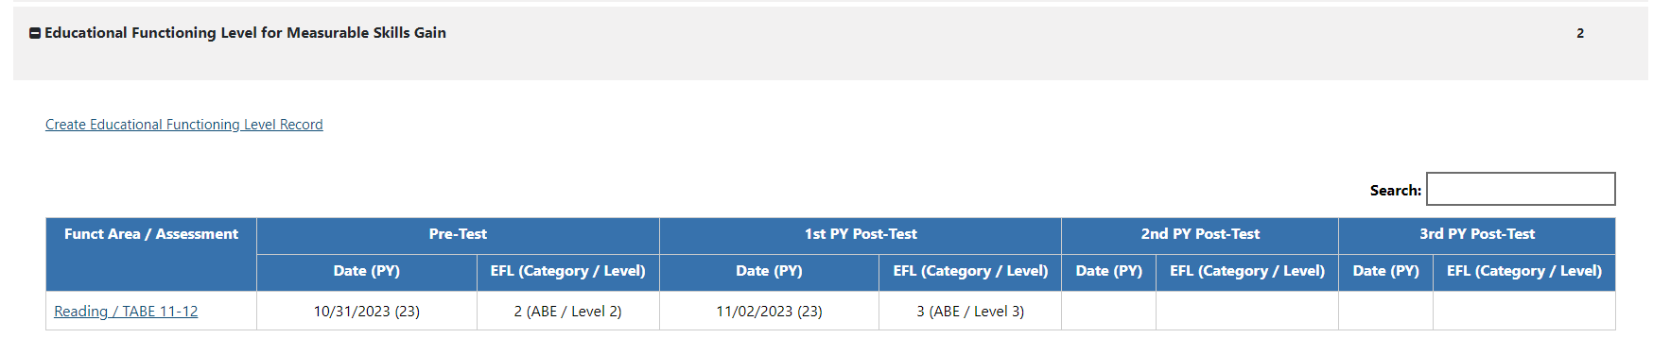

**Postsecondary following secondary.** Following completion (successful or unsuccessful) of secondary-level training and program exit, staff documents enrollment in postsecondary training. Staff selects Create Measurable Skills Gain. Select Skill Type: Credits Attained for EFL OR Completed Secondary Ed and Enrolled in Post-Secondary Ed.

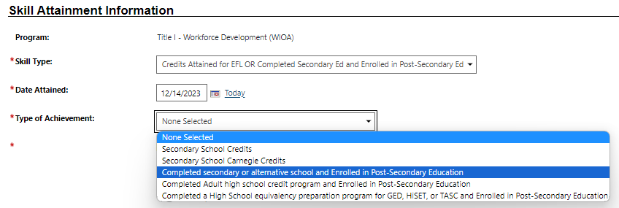

Date Attained:

The Date Attained entry must be the date of enrollment in training, not the date staff are notified or verify enrollment. To qualify as an MSG, the enrollment date must be entered after a participant exits from the program but during the program year.

Type of Achievement:

Staff must select the appropriate type of achievement based on secondary-level training completion.

## High School Equivalency

HSE gains refer to the documented attainment of a secondary-school diploma or its recognized equivalent. A participant must be enrolled in basic education, secondary education, or an HSE preparatory course during the period of participation.

This MSG

may be counted toward the Credential Rate numerator if the participant was enrolled in postsecondary education at any time during the 365 days following exit or was employed in any of the four calendar quarters following exit. Staff must document credential outcomes in the Credential or Follow-up ribbon in WorkInTexas.com.

**Data Entry:** Staff selects Create Measurable Skills Gain. Select Skill Type: Credits Attained for EFL OR Completed Secondary Ed and Enrolled in Post-Secondary Ed.

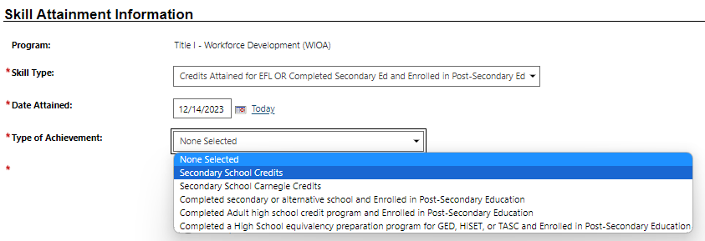

Date Attained:

Staff may enter

* The date that the participant completed the final requirements to earn the diploma or equivalent[1]

Type of Achievement:

Staff must select Secondary School Credits. Secondary School Carnegie Credits do not apply to Texas. Carnegie units are applicable to states that implement adult high schools.

## Report Card or Transcript Showing Satisfactory Progress

The report card or transcript shows that a participant is achieving the state unit’s academic standards, as follows:

* Secondary education (Grades 9–12)—Report card or transcript (youth only) for one semester showing that the participant is achieving academic standards.[2]
* Postsecondary education—Completion of sufficient postsecondary credit hours (or equivalent[3]) as demonstrated by one of the following:
* For full-time students, at least 12 hours in one semester during the program year
* For part-time students, at least 12 hours over two completed semesters within a 12-month period that ends in the program year

**Secondary.** Staff selects Create Measurable Skills Gain. Select Skill Type: Secondary Transcript/Report Card.

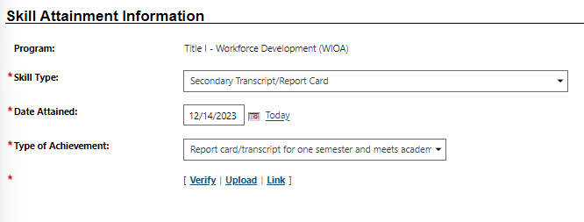

Date Attained:

Staff must enter the last day of the semester for which the report card demonstrating MSG requirements are met was issued, not the date staff receives the transcript or report card.

Type of Achievement:

Staff must select Report card/transcript for one semester and meets academic standards.

**Post-secondary.** Staff selects Create Measurable Skills Gain. Select Skill Type: Post-Secondary Transcript/Report Card.

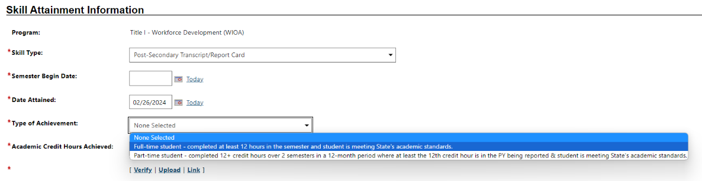

Semester Begin Date:

Staff must enter the date the student began postsecondary training. If the student is part-time, staff enters each semester separately and TWC calculates MSG status.

Date Attained:

Staff must enter the last day of the semester for which the report card demonstrating MSG requirements are met was issued, not the date staff receives the transcript or report card.

Type of Achievement:

Staff must select the appropriate achievement type based on the student’s full-time or part-time[4] status.

Academic Credit Hours Achieved:

Staff must enter the amount of credit hours achieved during the time frame. If contact hours were provided, staff must calculate the credit hour equivalent and enter that amount.

## Training Milestone through a Satisfactory or Better Progress Report

Report from an employer or training provider documenting the participant’s achievement of established milestones, such as completion of on-the-job training (OJT), completion of one year of an apprenticeship program, or similar milestones. This may be documented with a satisfactory or better progress report from the employer or training provider.

Increases in rate of pay resulting from newly acquired skills or increased performance also may be used to document progress. (This does not include greater pay from working additional hours.)

Progress reports may include training reports of milestones completed as participants master required job skills. Examples include successful completion of an OJT program or one year of a registered apprenticeship program.

**Data Entry:** Staff selects Create Measurable Skills Gain. Select Skill Type: Training Milestone.

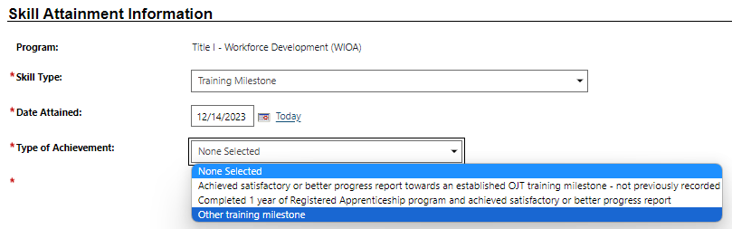

Date Attained:

Staff must enter the date that the employer or training provider indicated that the milestone was met, not the date staff are notified or verify the achievement.

Type of Achievement:

Staff must select the appropriate achievement type. If the training milestone does not apply to OJT or registered apprenticeship program enrollment, select Other training milestone.

## Skills Progression through the Passage of an Exam

A Skills Progression gain involves the successful passage of an exam that is required for an occupation and to progress in attaining technical or occupational skills as evidenced by trade-related benchmarks such as knowledge-based exams.

“Exam passed” may include passing a component exam in a registered apprenticeship program or an employer-required knowledge-based exam, satisfactory attainment of an element on an industry or occupational competency–based assessment, or other completion test necessary to obtain a credential.

Note: Passing a test in an academic course by participants enrolled in a traditional secondary or postsecondary education program is not considered a gain for this MSG type.

**Data Entry:** Staff selects Create Measurable Skills Gain. Select Skill Type: Skills Progression.

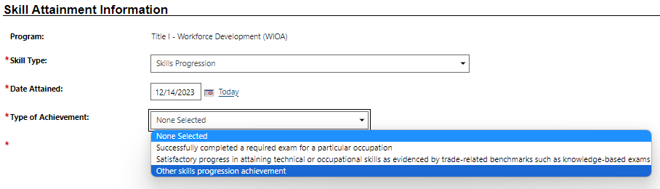

Date Attained:

Staff must enter the day the exam was completed by the student, not the date staff are notified or verify completion.

Type of Achievement:

Staff must select the appropriate achievement, including a certificate of completion of an occupational exam, training benchmarks, or other documented skills progress. Staff must limit selections of the trade-related benchmarks option to TAA participants.

## Verification of Measurable Skill Gains

Staff must validate each MSG through appropriate documentation. Workforce Solutions Office staff must identify the document used to validate achievement of MSGs (other than pretest/posttest EFL gains) in the Verify list in WorkInTexas.com. Staff may validate the pretest and posttest assessment outcomes by entering the results in the Educational Functioning Level for Measurable Skills Gain ribbon in WorkInTexas.com and retaining the assessment documents.

Acceptable validation sources are as follows:

* + - * EFL gain:
        + Employed/Enrolled: Case Notes
        + Employed/Enrolled: School records or verification of enrollment
        + Employed/Enrolled: Transcript or report card
      * HSE:
        + Transcript
        + Report Card
      * Report card or transcript showing satisfactory progress:
        + Transcript
        + Report Card
      * Training milestone as demonstrated by a satisfactory or better progress report:
        + Milestone: Documentation of a skill gained through OJT or Registered Apprenticeship
        + Milestone: Contract and/or evaluation from employer or training provider documenting a skill gain
        + Milestone: Progress report from an employer documenting a skill gain
      * Skills progression as demonstrated by the successful passage of an exam:
        + Skills Gain: Results of knowledge-based exam or certification of completion
        + Skills Gain: Documentation demonstrating progress in attaining technical or occupational skills through an exam or benchmark attainment
        + Skills Gain: Documentation from a training provider or employer
        + Skills Gain: Copy of a credential that is required for a particular occupation and only is earned after the passage of an exam

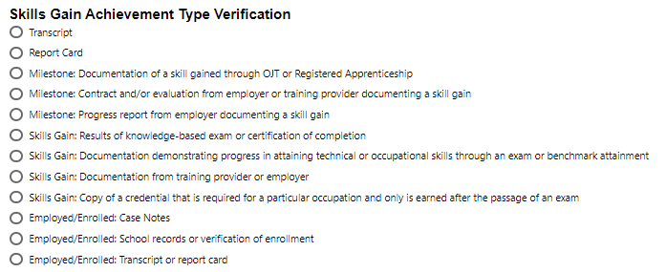

1. This is used only in rare instances when coursework and required tests were successfully completed in one program year, but the actual diploma or equivalent was issued at the beginning of the next program year. The diploma or equivalent must be counted only once. Boards must not record a diploma or equivalent for both dates.
2. Texas Education Code (TEC) §28.021(a) and §28.021(d): §28.021 (a) “A student may be promoted only on the basis of academic achievement or demonstrated proficiency of the subject matter of the course or grade level.” §28.021(d) “By the start of the school year, a district shall make public the requirements for student advancement under this section.”
3. Fifteen contact hours may be counted toward a single credit hour equivalent for students enrolled in institutions of higher education. [TEC §4.6](https://texreg.sos.state.tx.us/public/readtac$ext.TacPage?sl=R&app=9&p_dir=&p_rloc=&p_tloc=&p_ploc=&pg=1&p_tac=&ti=19&pt=1&ch=4&rl=6) states that, in general, for public institutions of higher education in Texas, three semester credit hour courses will contain “45 to 48 contact hours depending on whether there is a final exam.”
4. Staff must be aware that this MSG may be documented for part-time students who complete 12 credit hours in any two semesters within a 12-month period.